**Linux Flavours:-**

RedHat

CentOS

Ubuntu

Suse

Debian

Fedora

**Commands to setup ipaddress to a virtual machine created:-**

* Ifconfig 🡺 To check whether ip assigned to a linux machine.

**Note:** if “ifconfig” doesn’t work “ip a” is the command for newest version of linux machine.

* ifup np0s3 🡺 To assign an ip to a VM

**Linux commands:-**

* su - 🡺 stands for switch user, to turn as a root user.
* Ping 🡺 To know the status of any application
* Hostname 🡺 To return the current host name

**Changing the password:-**

* Who am i / whoami 🡺 To know the current logged in user
* Passwd username 🡺 To change the user password as a root user.

Note : To change the user password you should login as root user.

* Passwd 🡺 To change the password of current logged in user

**File System Commands:-**

* cd / 🡺 To switch to a root folder
* ls 🡺 To list down the folders available in path
* ls –l or ls -ltr 🡺 To list down the entire file system structure with permissions we have.
* ls –a 🡺 It will return all the files and directories including hidden (name starts with .)

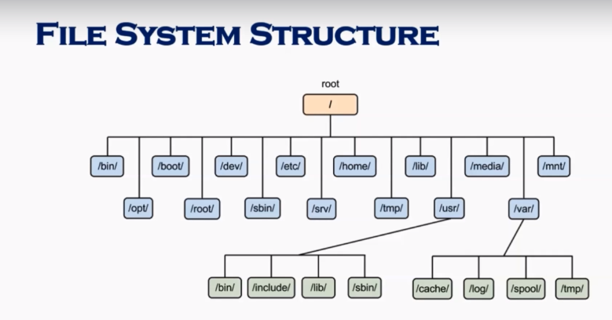

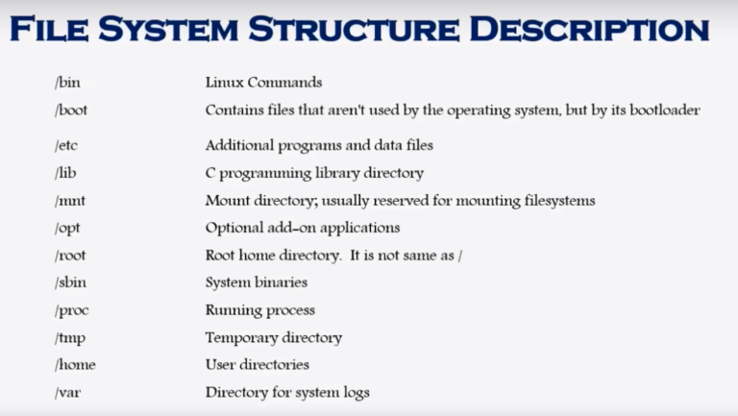

**File System Navigation Commands:-**

* cd 🡺 change directory, a primary command to moving around the file system.
* Cd .. 🡺 To switch to previous directory.
* Cd / 🡺 To switch to root folder
* Pwd 🡺 Stands for Print Working Directory, it tells where your current location is.
* ls -l 🡺 Stands for list it lists all the files/directories under the current working directory.

**File System Paths:-**

There are two paths to navigate to a file system

* Absolute path

An absolute path always start with a “/”. This indicates the path always start with root directory.

e.g:- cd /var/log/samba

* Relative path

A relative path doesn’t start with a “/”. It indicates a location relative to your current position.

e.g:-

cd /var

cd log

cd samba

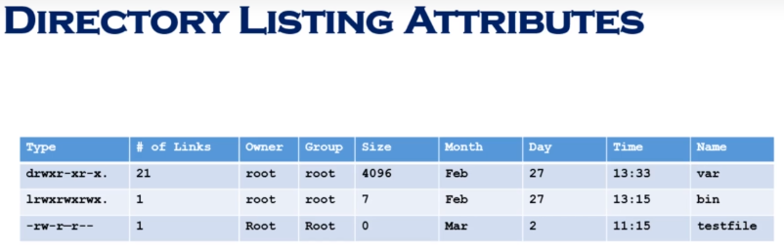

**Creating files and directors:-**

**Creating files -**

* **touch 🡺** To create a file
* **cp 🡺** To copy and paste the file
* **vi 🡺** To create and edit the file

**Creating directory –**

* **mkdir 🡺** To create a directory.

**Find files and directories in Linux:-**

* **find 🡺** Will work when we need to perform search on tons of files

e.g –

find . –name “file name”

* **locate 🡺** Will work efficiently for short searches

e.g-

locate “file name”

**Wildcards:-**

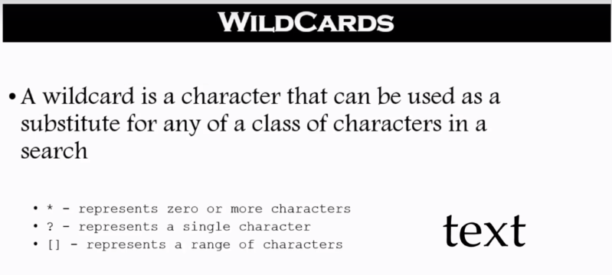

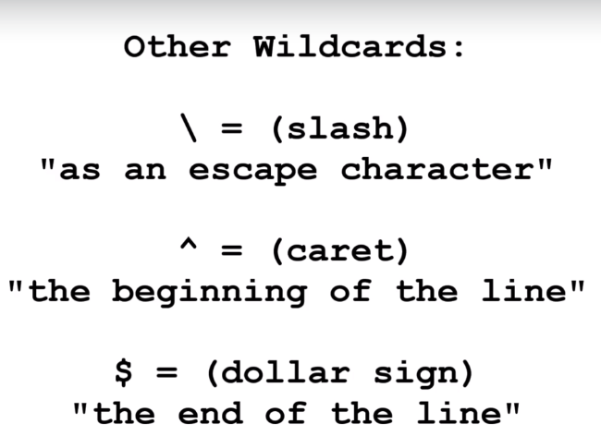

**Pipe:-**

* Pipe is user by the shell to connect output of one command directly to the input of another command.
* The symbol for a pipe is the vertical bar (|) . The syntax is:

Command1[arguments] | command2[arguments]

e.g:- ls - l | more

**File permissions:-**

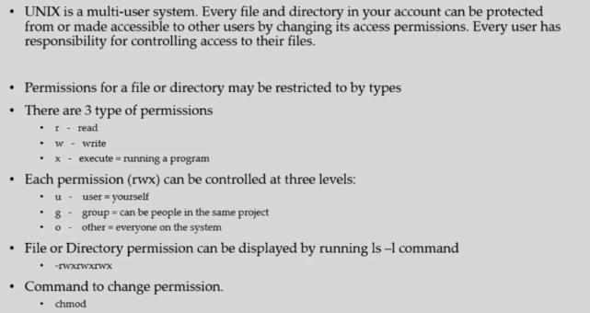

**Remove Permissions to USER:-**

e.g 1 :- To remove the READ permission to user

🡺 chmod u –r filename

e.g 2 :- To remove the WRITE permission to user

🡺 chmod u –w filename

e.g 3 :- To remove the EXCUTE permission to user

🡺 chmod u –x filename

**Remove Permissions to GROUP:-**

e.g 1 :- To remove the READ permission to group

🡺 chmod g –r filename

e.g 2 :- To remove the WRITE permission to group

🡺 chmod g –w filename

e.g 3 :- To remove the EXCUTE permission to group

🡺 chmod g –x filename

**Remove Permissions to OTHERS:-**

e.g 1 :- To remove the READ permission to others

🡺 chmod o –r filename

e.g 2 :- To remove the WRITE permission to others

🡺 chmod g –w filename

e.g 3 :- To remove the EXCUTE permission to others

🡺 chmod g –x filename

Add permissions to user / group / others will suffice like same above by replacing – with +

**Help Commands:-**

There are three help commands in Linux

* whatis command

short description about the command

* command –help

It will give you longer description of command and options we have under this command.

* man command

It will give you the detailed and user friendly help about the command you are looking for.

**File Ownership:-**

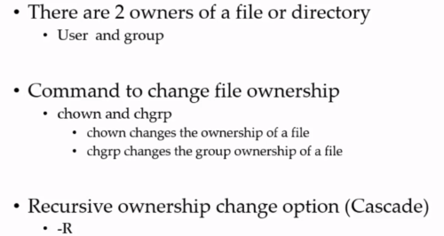

* -R 🡺 This command change the ownership of files and directories under the directly you are currently in.
* If you have permission over directory, although you don’t have permissions over files/directories inside the directory, you will get an explicit permission due to the permission you have over base directory.
* chgrp 🡺 Command to change the group ownership of file/directory

e.g:- chgrp root file/directory name you want to change owner group

==> chown 🡺 Command to change the ownership of file/directory

==> Note : we can also change owner ship of user and group at a time by following command.

chown username:groupname file/directory you want to change.

**Adding text to files:-**

3 simple ways to add text/numbers to files

* vi
* echo > or >>

e.g:- echo “text/numbers you want to add” > filename to which you want to add

e.g:- echo “text/numbers you want to add” >> file name to which you want to add

>> - which is to add content without remove the existing .

> - which is to add content by removing the existing .

* Redirect command output > or >>

Using this command we put the output of first command into a file.

e.g:- ls –l > filename you want to put the output of ls –l command by overwriting the existing.

e.g:- ls –l > filename you want to put the output of ls –l command to add to the existing content.

**File system maintenance commands:-**

* cp 🡺 To copy file from one directory to another

cp SourceFileName DestinationFileName

e.g:- cp test1 test3

* rm 🡺 To remove file
* mv 🡺 Move the file from one directory to another
* rmdir or rm -r 🡺 To remove directory
* mkdir 🡺 To create directory
* chgrp 🡺 To change the ownership of a file/directory at the group level
* chown 🡺 To change the ownership of a file/directory at the user level

**File Display Commands:-**

* cat 🡺 To see entire content of a file

cat test1 🡺 Will return the whole content from file test1

* more 🡺 It allows you to see the one page content of a file at a time

more test1 🡺 Will return the first page content from file test1

* less 🡺 It allows you to see the one line content at a time in reverse order

less test1 🡺 Will return the last page content from file test1

* head 🡺 To see how many lines we want to see from top of file

tail -1 test1 🡺 will return first one line from the file test1

* tail 🡺 To see how many lines we want to see from bottom of file

tail -1 test1 🡺 will return last one line from the file test1

**Filters / Text processer commands:-**

* cut

To written specific range of characters from each line in a file

e.g:- cat –c1 filename 🡺 It will return first character of each line in a given file name.

e.g:- cat –c2 filename 🡺 It will return second character of each line in a given file name.

e.g:- cat –c1-2 filename 🡺 It will return first two characters of each line in a given file name.

* Awk

To written specific word from the sentence in a file

e.g:- awk ‘{print $1}’ filename 🡺 This command will return the first word from each line of the file.

e.g:- awk ‘{print $2}’ filename 🡺 This command will return the second word from each line of the file.

e.g:- awk ‘{print $1}’ filename 🡺 This command will return the first from each line of the file.

The same command also return in different way using pipe(|) command.

e.g:- cat filename | awk ‘{print $1}’

* grep

This command is useful like a search, will return results based on the search keyword present in test file.

e.g:- grep “text you want to search” “filename”

* sort

To return results in sorting order, also –r can be used to return results in reverse order.

* uniq

To remove the duplicates from results

* wc

To get the word count from a specified file.

e.g:- wc filename

e.g:- wc –l filename 🡺 This will return the number of lines in a file

e.g:- wc –w filename 🡺 This will return the number of words in a file.

e.g:- wc –c filename 🡺 This will return the number of characters in a file

**Compare files:-**

* diff 🡺 It compares two files line by line
* cmp 🡺 It compares two lines byte by byte.

**Compress and un-compress files:-**

* tar 🡺 tarring is to put all files together

tar cvf “foldername.tar” “path of the folder you want to zip”

e.g:- tar compress.tar cvf /home/Ravi/ 🡺 This will compress the files available under /home/Ravi and create a compressed file call compress.tar

e.g:- tar xvf compress.tar 🡺 This command will extract all the files from compress.tar

* gzip 🡺 to compress the directory to reduce the size
* gzip –d or gunzip 🡺 to un compress the compressed file.

**Linux file editor:-**

* vi 🡺 Visual Editor
* ed 🡺 Standard line editor
* ex 🡺 Extended line editor
* emacs 🡺 A full screen editor
* pico 🡺 Beginners editor
* vim 🡺 Advanced version of vi

**vi – Is most popular Editor available in almost all flavours of linux.**

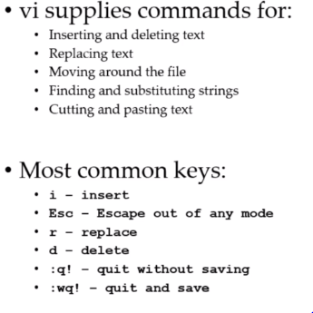

**User account management:-**

**Commands**

* useradd

e.g:- useradd spiderman 🡺 This command create user and group with the name spiderman

e.g:- id spiderman 🡺 To check whether spiderman user and group is created.

* groupadd

e.g:- groupadd superheros 🡺 This command creates a group called superheros

e.g:- cat /etc/group 🡺 This command results the groups available in group file under /etc.

* userdel

e.g:- userdel -r username 🡺 This will delete the specified user name.

* groupdel

e.g:- groupdel –r groupname 🡺 This will delete the group

* usermod 🡺 To add users to a group

e.g:- usermod –G Ravindra superheros 🡺 This command will add user Ravindra to group superheros

e.g:- chgrp –R superheros Ravindra 🡺 To remove user from group Ravindra and add to superheros, also, -R to give access all file and directories recursively.

**Files**

* /etc/passwd 🡺 which contains the information about all user details
* /etc/group 🡺 which contains the information of all groups
* /etc/shadow 🡺 which contains the information of users which we created

Note :- To manage users/permissions we need to access the console as root.

**Switch users and sudo access:-**

**Commands**

* su – username 🡺 To switch to other user
* sudo command 🡺 To run the commands as root user
* visudo 🡺 To edit the sudoer file

**File**

* /etc/sudoers

**Monitor users:-**

* who 🡺 It returns the list of users logged in after session opened.
* last 🡺 It returns the list of users logged in from starting.
* W 🡺 It returns the list of users logged in after session opened along with the idle status and processes ran.
* Finger 🡺 Need to install explicitly to know the logged/accessed user details fully.
* id 🡺 To know about the user details and which group belongs to.

**System utility commands:-**

* date 🡺 To return the system date and time
* uptime 🡺 To return up time
* hostname 🡺 To return the host name
* uname 🡺 To return OS name
* which 🡺 To find the running command location
* cal 🡺 To return calendar of current month
* bc 🡺

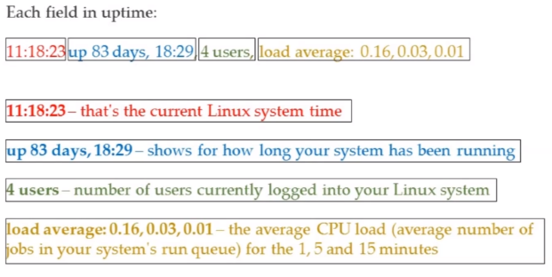

**Processes and jobs:-**

* Application = Service

Program which runs in your machine such as Microsoft applications, chrome

systemctl or service 🡺 To start, stop and restart process

1. systemctl start servicename
2. systemctl stop servicename
3. systemctl restart servicename
4. systemctl enable servicename 🡺 Start the service automatically whenever we switch on the linux machine.

ps 🡺 This helps to see what are processes running in our system.

1. ps -ef

top 🡺 To get the list of processes running in our system and other details

kill 🡺 To kill the process with the process name and

1. kill servicename/id

crontab 🡺 To schedule jobs for multiple runs

mm hh dd mm yyyy commands which we want to excute.

at 🡺 To add schedule job for one time run

* Script

Commands or list of commands which runs in our machine in background which is support script to run apache.. etc

* Process

When we start any application it will start the process.

* Deamon

This runs always in background to support the application to listen the traffic of that particular application.

* Thread

A process could have multiple threads which helps to connect multiple systems.

Service 🡪 Process 🡪 Thread1.. Thread2.. Thread3.. etc

* Job or workorder 🡺 Run a service or process at a schedule time.

**System Monitoring:-**

* top
* df – It will show the details about disk size used
* du – command to show which file occupied more space which will help to free up the space.
* dmesg – Gives you the warnings and errors which system thrown
* iostat 1

iostat 🡺 command gives you the input and output statistics without refresh

iostat 1 🡺 gives you the input and output stats with each second refresh

* netstat

netstat –nvf 🡺 To know the gateway information

netstat 🡺 It will show all the connected/disconnected system details running in sync with our system.

* free

which will give us the details about physical memory and swap memory virtually utilizing in our system.

* cat /proc/cpuinfo

To know about cpu information

* cat /proc/meminfo

To know about memory information.

**System maintenance:-**

* shutdown
* init0-7
* reboot
* halt

**changing system host name:-**

* hostnamectl set-hostname newhostname
* Version 7 = Edit /etc/hostname
* Version 6 = Edit /etc/sysconfig/network

**Finding system information:-**

* cat /etc/redhat-release
* uname –a
* dmidecode

**What is kernel:-**

* Kernel is a program which run between hardware and software in Linux

**What is shell:-**

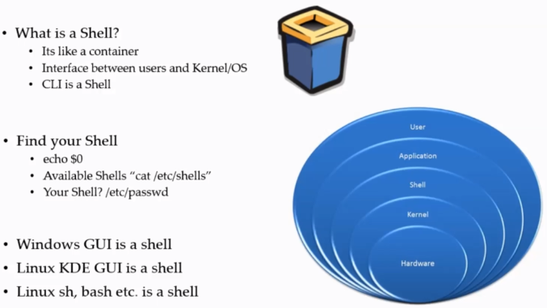

**Shell scripting:-**

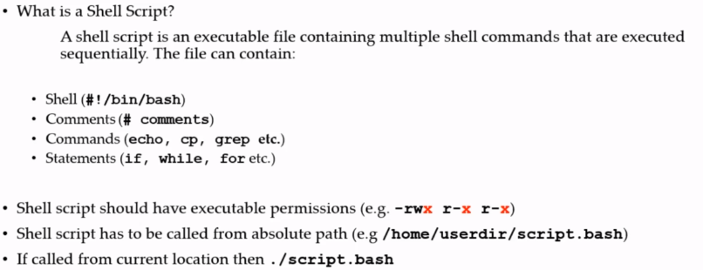

**Aliases:-**

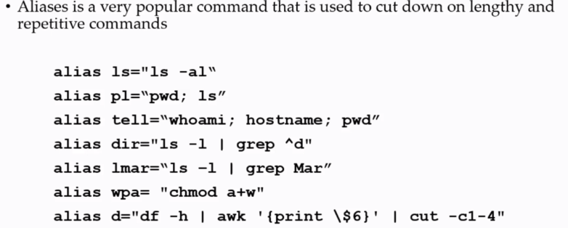

**Shell history:-**

* command history.

We can re-run same command in two ways

1. Copy and paste the original command
2. By running the command number available in history output 🡺 !406 etc...

**Network files and commands**